**Predicting the Ending of a Sporting Event from Traffic Data**

Nick Romano, [nromano@bellarmine.edu](mailto:nromano@bellarmine.edu)

Trevor McCormick, [tmccormick2@bellarmine.edu](mailto:tmccormick2@bellarmine.edu)

**ABSTRACT**

Up to 150 word summary of your project.

1. **INTRODUCTION**

The data set that we are working with is the Dodgers Loop Sensor Data Set that is part of the UCI Machine Learning Repository. The Dodgers Loop Sensor Data Set came with a few files: Dodgers.events, Dodgers.data, Dodgers.name. The Dodgers.events file is a comma separated file that contains the entries of the date, starting time, ending time, total game attendance, opponent, and result of the Los Angeles Dodgers’ home games for the 2005 MLB season. The Dodgers.data file is a comma separated file that contains entries of car count for the 101 North Freeway Glendale on ramp at 5-minute intervals from April 10, 2005, to October 1, 2005, which was just before the first Dodgers home game and last Dodgers home game. The Dodgers.name file is just a file that describes the other two files. In the Dodgers.name file,

Given the 2005 schedule information, the traffic count of 5-minute intervals, our goal is going to be predicting whether a Dodgers game is underway.

1. **BACKGROUND**

The Los Angeles Dodgers play their home games at Dodger Stadium in Los Angeles, California. Using censor data from the Freeway Performance Measurement System (PeMS), which is an online traffic database that gathers traffic data from sensors, Jon Hutchins was able to gather data on the count of cars on 5-minute intervals for the Glendale on ramp for the 101 North Freeway. Jon Hutchins notes in the Dodgers.name file that the Glendale on ramp to the 101 North Freeway is near Dodger Stadium to see an increase in the flow of traffic for the on ramp but is not too heavily used by the total game traffic. As mentioned earlier, this ramp sees traffic at around the end of a Dodgers game. Using Google Earth, we think that we have found the ramp that the data set is referring to. In Figure One, the red pin on the map is a on ramp for the 101 North Freeway just off Glendale Boulevard and on the right half of the figure is Dodger Stadium. With the traffic data for the Glendale on ramp, the attribute that the author was trying to predict was the presence of a Dodgers baseball game.

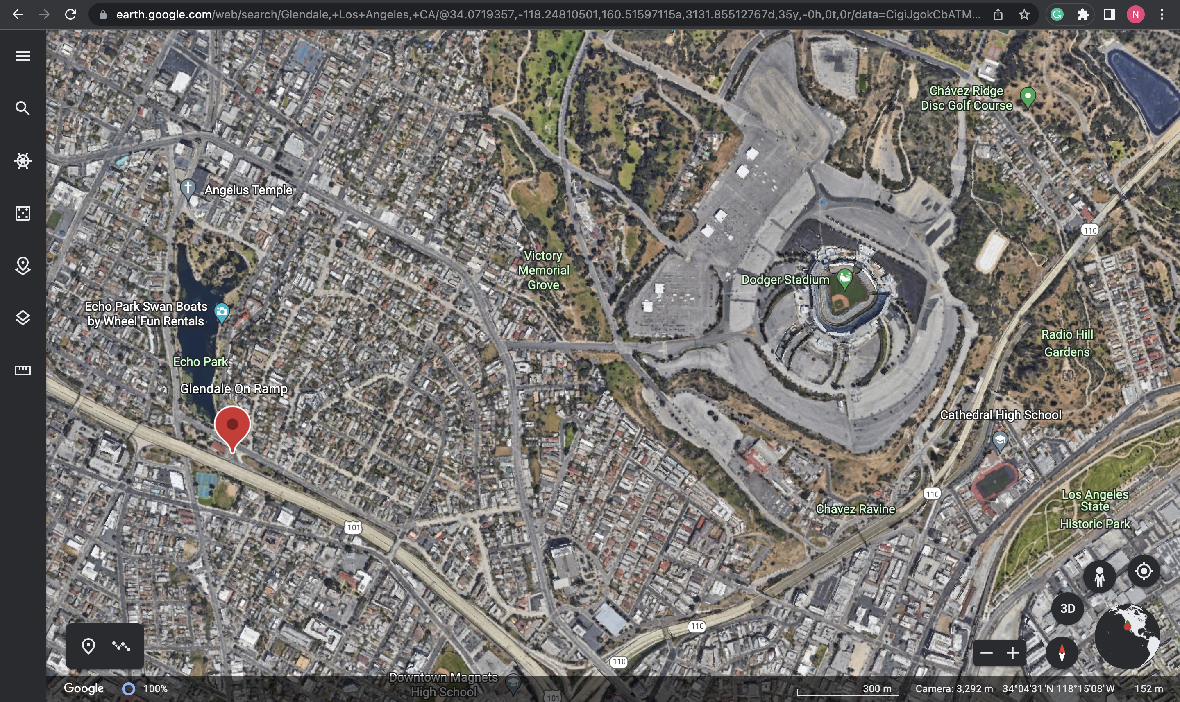

**Figure 1: The 101 North Freeway Glendale on ramp and Dodgers Stadium (Google Earth)**

1. **EXPLORATORY ANALYSIS**

This traffic data set that we were analyzing contains 47,497 rows and 5 columns that have various different data types. These can be found in **Table 1**. In this table, we are indicated what each of the columns in the data set is named, as well as what its data type is. In our data set, we have ordinal, interval, ratio, and nominal data. Normally in an exploratory data analysis you would focus on all or most of your statistics and plots. However, in this analysis we are mainly focusing on those that are unusual or skewed data.

**Table 1: Data Types**

|  |  |
| --- | --- |
| *Variable Name* | *Data Type* |
| Week_Day | Int64/Ordinal |
| Hour | Int64/Interval |
| Minute | Int64/Interval |
| Traffic_Count | Int64/Ratio |
| Game_Ended | Int64/Nominal |

In our data set, we noticed fairly early on that we had an imbalance between data points that are between game intervals and non-game data points. Our value counts for Dodgers games were 4,119 and 43,378 for no Dodgers game. A drastic difference. A difference like this would make interpreting and working with the data much more difficult than it needs to be.

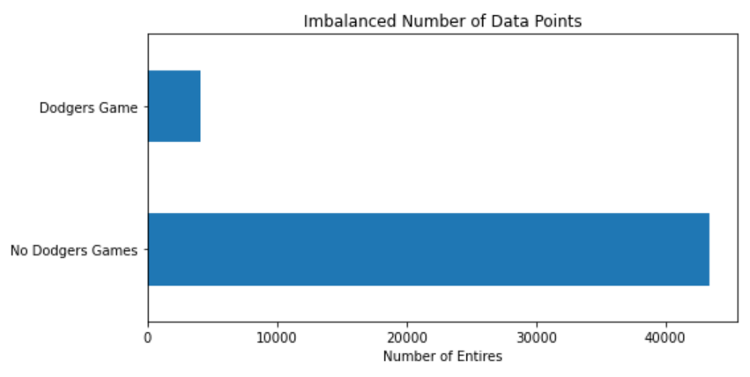

**Figure 2: Imbalanced Data Points**

Due to this drastic difference in the number of entries that do and do not occur around a Dodgers game (seen in **Figure 2**), we decided to resample the traffic dataset to include a total of 4200 data points of traffic for when there was no dodgers game happening, in order to balance out this unusual dataset. Now the balanced data set has 8319 entries with 5 columns.

1. **METHODS**
   1. *Data Preparation*

Since we wanted to two different files, we first started at the Dodgers.games dataset. We wanted to use the start and end times from that file and store it somehow as the target for the Dodgers.data dataset. However, the date, start time, and end time were 3 separate columns. But we wanted to combine these columns in a way that would have just the start time and end time of each Dodgers game in Datetime form. To combine the Date and End time columns, we converted these columns into strings and concatenated them with a space in between, then we converted that result into Datetime form and stored the value within the Endtime column. We did this same strategy with the Date and Startime columns and stored the resulting datetime value within the Date column. Then we dropped the Starttime column, since the needed data was now within the Date column, then renamed the Date column as Starttime. To use these new times to get our target value

Since we are trying to predict whether a Dodgers baseball game is taking place, we added a column to the df_traffic data frame that has a 1 indicating the times a Dodgers game and 0 no Dodgers games. In determining the occurrence of a baseball game, we decided to create a window of time just before the start and after the end of a baseball game since we are using traffic data, traffic builds up leading up to and after the game. We added a "Game" column to the data frame with an initial value of 0 and added 1 to any index value that is in the occurrence list. So, 1 represents a Dodgers Game and no game at 0.

For the data preparation we applied trigonometric transformations on the day of week, hour, and minute from the time of the 5 minute intervals of the sensor data. We followed the code from the *Toward Data Science* article “Cyclical features encoding, it’s about time!” Pierre-Louis Bescond. In doing so we normalized the day of the weeks, hour, and minute so that they are between pi and 2pi. Furthermore, we took the sin and cos of each of the normalized values of the day of the weeks, hour, and minute. We had calculated the sine and cosine values, since Pierre-Louis Bescond explained that if we just found the cosine value there would be different times that take on the same value. In calculating the sine value are giving another datapoint to help distinguish the different components of time. We did this so that the time data will preserve its cycle nature. In doing this, we expanded the dataset to now contain 13 features and a target. The 13 features are day of week, day of week normalized, day of week normalized with cosine transformation, day of week normalized with sin transformation, hour, hour normalized, hour normalized with cosine transformation, hour normalized with sin transformation, minute, minute normalized, minute normalized with cosine transformation, minute normalized with sin transformation, and traffic.

* 1. *Experimental Design*

Table 2: Experiment Parameters K Nearest Neighbor Classifier

|  |  |
| --- | --- |
| **Experiment Number** | **Parameters** |
| 1 | All 13 features with 80/10/10 split for train, validate and test |
| 2 | 3 interval features and 1 ratio feature with 80/10/10 split for train, validate and test; |
| 3 | All six cos and sin transformed features with 70/10/10 split for train, validate, and test; |

Table 3: Experiment Parameters Random Forest Classifier

|  |  |
| --- | --- |
| **Experiment Number** | **Parameters** |
| 1 | All 13 features with 80/10/10 split for train, validate and test |
| 2 | 3 interval features and 1 ratio feature with 70/15/15 split for train |
| 3 | All six cos and sin transformed features with 70/15/15 split for train, validate, and test |

* 1. *Tools Used*

The following tools to perform the analysis: Python v3.8.8 running the Anaconda 4.12.0 environment on an Apple Macintosh computer was used for all of the analysis and implementation. In addition to the following libraries were also used: Pandas 1.2.4, Numpy 1.20.1, Matplotlib 3.3.4, Seaborn 0.11.1, and SKLearn 0.24.1.

Python v3.8.8 that was running the Anaconda 4.12 environment was chosen for the analysis since our group was more familiar with using Python than say R and RStudio. On top of that, the Pandas library was used in the analysis in order to be able to easily work with the data with DataFrames. Numpy was used to help creating arrays for the processing of our models. Matplotlib and Seaborn were both used to help generate graphs. SKLearn was used for running the machine learning algorithms.

|  |
| --- |
|   **Figure 3: Confusion Matrix: KN Classifier Parameter 1** |

1. **RESULTS**
   1. *Classification Measures*

**Table 5: KN Classifier Parameter 1 Classification Report**

|  |  |  |  |
| --- | --- | --- | --- |
|  | precision | recall | F1-score |
| 0 | .87 | .79 | .83 |
| 1 | .81 | .89 | .85 |
|  |  |  | accuracy: .84 |

|  |
| --- |
|   **Figure 4: Confusion Matrix: KN Classifier Parameter 2** |

**Table 6: KN Classifier Parameter 2 Classification Report.**

|  |  |  |  |
| --- | --- | --- | --- |
|  | precision | recall | F1-score |
| 0 | .87 | .77 | .82 |
| 1 | .80 | .89 | .84 |
|  |  |  | accuracy: .83 |

|  |
| --- |
|   **Figure 5: Confusion Matrix: KN Classifier Parameter 3** |

**Table 7: KN Classifier Parameter 3 Classification Report**

|  |  |  |  |
| --- | --- | --- | --- |
|  | precision | recall | F1-score |
| 0 | .86 | .80 | .83 |
| 1 | .81 | .87 | .83 |
|  |  |  | accuracy: .84 |

|  |
| --- |
|   **Figure 6: Confusion Matrix: Random Forest Parameter 1** |

**Table 8: Random Forest Parameter 1 Classification Report.**

|  |  |  |  |
| --- | --- | --- | --- |
|  | precision | recall | F1-score |
| 0 | .85 | .87 | .86 |
| 1 | .86 | .84 | .85 |
|  |  |  | accuracy: .85 |

|  |
| --- |
|   **Confusion Matrix: Random Forest Parameter 2** |

**Table 9: Random Forest Parameter 2 Classification Report.**

|  |  |  |  |
| --- | --- | --- | --- |
|  | precision | recall | F1-score |
| 0 | .91 | .87 | .89 |
| 1 | .87 | .91 | .89 |
|  |  |  | accuracy: .89 |

|  |
| --- |
|   **Confusion Matrix: Random Forest Parameter 3** |

**Table 10: Random Forest Parameter 3 Classification Report**

|  |  |  |  |
| --- | --- | --- | --- |
|  | precision | recall | F1-score |
| 0 | .87 | .78 | .82 |
| 1 | .79 | .89 | .84 |
|  |  |  | accuracy: .83 |

* 1. *Discussion of Results*
  2. *Comparison of Models*
  3. *Problems Encountered*
  4. *Limitations of Implementation*
  5. *Improvements/Future Work*

1. **CONCLUSION**

**REFERENCES**

Google. (n.d.). [Google Map of Dodger Stadium and 101 North Freeway Glendale Boulevard on Ramp]. Retrieved April 26, 2022, from <https://earth.google.com/web/search/Glendale,+Los+Angeles,+CA/@34.0719357,-118.24810501,160.51597115a,3131.85512767d,35y,-0h,0t,0r/data=CigiJgokCbATMvZYCUFAEbifTHJxCEFAGcGD0S8qkF3AIenLEE0fkV3A>

Pierre-Louis Bescond (2020). *Cyclical features encoding, it’s about time!* Towards Data Science. Retrieved April 31, 2022, from <https://towardsdatascience.com/cyclical-features-encoding-its-about-time-ce23581845ca>

*Division of Labor*